|  |  |
| --- | --- |
| Activity | Data Type |
| Number of beatings from Wife | Integer |
| Results of rolling a dice | Integer |
| Weight of a person | Float |
| Weight of Gold | Float |
| Distance between two places | Float |
| Length of a leaf | Float |
| Dog's weight | Float |
| Blue Color | String |
| Number of kids | Integer |
| Number of tickets in Indian railways | Integer |
| Number of times married | Integer |
| Gender (Male or Female) | String |
|  |  |

Q1) Identify the Data type for the Following:

Q2) Identify the Data types, which were among the following

Nominal, Ordinal, Interval, Ratio.

|  |  |
| --- | --- |
| Data | Data Type |
| Gender | Nominal |
| High School Class Ranking | Ordinal |
| Celsius Temperature | Interval |
| Weight | Ratio |
| Hair Color | Nominal |
| Socioeconomic Status | Ordinal |
| Fahrenheit Temperature | Interval |
| Height | Nominal |
| Type of living accommodation | Ordinal |
| Level of Agreement | Nominal |
| IQ(Intelligence Scale) | Ordinal |
| Sales Figures | Interval |
| Blood Group | Nominal |
| Time Of Day | Interval |
| Time on a Clock with Hands | Nominal |
| Number of Children | Nominal |
| Religious Preference | Ordinal |
| Barometer Pressure | Interval |
| SAT Scores | Ordinal |
| Years of Education | interval |

Q3) Three Coins are tossed, find the probability that two heads and one tail are obtained?

1. 3/8

=0.375

Q4) Two Dice are rolled, find the probability that sum is

1. Equal to 1 = 1/6
2. Less than or equal to 4=1/6
3. Sum is divisible by 2 and 3=1/6

Q5) A bag contains 2 red, 3 green and 2 blue balls. Two balls are drawn at random. What is the probability that none of the balls drawn is blue?

1. 2/7+3/7+2/7= 12/21

2 balls are already drawn at random so ans = 10/12

Q6) Calculate the Expected number of candies for a randomly selected child

Below are the probabilities of count of candies for children (ignoring the nature of the child-Generalized view)

|  |  |  |
| --- | --- | --- |
| CHILD | Candies count | Probability |
| A | 1 | 0.015 |
| B | 4 | 0.20 |
| C | 3 | 0.65 |
| D | 5 | 0.005 |
| E | 6 | 0.01 |
| F | 2 | 0.120 |

Child A – probability of having 1 candy = 0.015.

Child B – probability of having 4 candies = 0.20

1. 3.09

Q7) Calculate Mean, Median, Mode, Variance, Standard Deviation, Range & comment about the values / draw inferences, for the given dataset

* For Points,Score,Weigh>

Find Mean, Median, Mode, Variance, Standard Deviation, and Range and also Comment about the values/ Draw some inferences.

|  |  |  |  |
| --- | --- | --- | --- |
|  | points | score | weigh |
| mean | 3.596 | 3.217 | 17.84 |
| mode | 3.07 | 3.44 | 17.02 |
| median | 3.695 | 3.325 | 17.710 |
| variance | 0.285 | 0.957 | 3.193 |
| Standard deviation | 0.534 | O.978 | 1.786 |
| range | 2.760 | 1.513 | 14.500 |

**Use Q7.csv file**

Q8) Calculate Expected Value for the problem below

1. The weights (X) of patients at a clinic (in pounds), are

108, 110, 123, 134, 135, 145, 167, 187, 199

Assume one of the patients is chosen at random. What is the Expected Value of the Weight of that patient?

1. 145.33

**Q9) Calculate Skewness, Kurtosis & draw inferences on the following data**

**Cars speed and distance**

**Use Q9_a.csv**

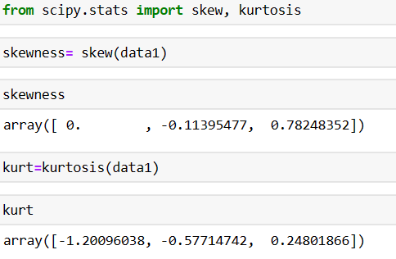

**A)**

|  |  |  |
| --- | --- | --- |
|  | **Speed** | **Distance** |
| **Skewness** | **-0.113** | **0.782** |
| **Kurtosis** | **-0.571** | **0.248** |

**SP and Weight(WT)**

**Use Q9_b.csv**

**A)**

|  |  |  |
| --- | --- | --- |
|  | **Sp** | **Weight** |
| **Skewness** | **1.581** | **-0.603** |
| **Kurtosis** | **2.723** | **0.819** |

**Q10) Draw inferences about the following boxplot & histogram**



* It is right skewed
* Outliers found between 250-400
* Median is greater than mean



* Box plot is used to find outliers for particular column.
* There are many outliers found in this boxplot
* It is positive skewed

**Q11)** Suppose we want to estimate the average weight of an adult male in Mexico. We draw a random sample of 2,000 men from a population of 3,000,000 men and weigh them. We find that the average person in our sample weighs 200 pounds, and the standard deviation of the sample is 30 pounds. Calculate 94%,98%,96% confidence interval?

|  |  |  |
| --- | --- | --- |
|  | T-score | Confidence_interval |
| 94% | 0.833 | 199.44 |
| 96% | 0.836 | 199.43 |
| 98% | 0.838 | 199.43 |

**Q12)** Below are the scores obtained by a student in tests

**34,36,36,38,38,39,39,40,40,41,41,41,41,42,42,45,49,56**

1. Find mean, median, variance, standard deviation.
2. What can we say about the student marks?

1A)

|  |  |
| --- | --- |
| Mean | 41.0 |
| Median | 40.5 |
| Variance | 24.11 |
| Standard_deviation | 4.91 |

2A) The average marks obtained by student is 41 and variance among students is 24 marks and the max marks obtained is 40 in every test.

Q13) What is the nature of skewness when mean, median of data are equal?

Normal distribution

Q14) What is the nature of skewness when mean > median ?

Negative skew

Q15) What is the nature of skewness when median > mean?

Positive skew

Q16) What does positive kurtosis value indicates for a data ?

Leptokurtic distribution

Q17) What does negative kurtosis value indicates for a data?

Platykurtic distribution

Q18) Answer the below questions using the below boxplot visualization.



What can we say about the distribution of the data?

Not normally distributed

What is nature of skewness of the data?

Negative skewness

What will be the IQR of the data (approximately)?

Between 10-18  
  
Q19) Comment on the below Boxplot visualizations?



Draw an Inference from the distribution of data for Boxplot 1 with respect Boxplot 2.

* Both are having normal distribution
* Mean and median are equal so there is no skewness
* Outliers are not found in this plot

Q 20) Calculate probability from the given dataset for the below cases

Data _set: Cars.csv

Calculate the probability of MPG of Cars for the below cases.

MPG <- Cars$MPG

* 1. P(MPG>38) = 0.347
  2. P(MPG<40) = 0.729
  3. P (20<MPG<50) = 0.013

Q 21) Check whether the data follows normal distribution

1. Check whether the MPG of Cars follows Normal Distribution

Dataset: Cars.csv

1. Normally distributed

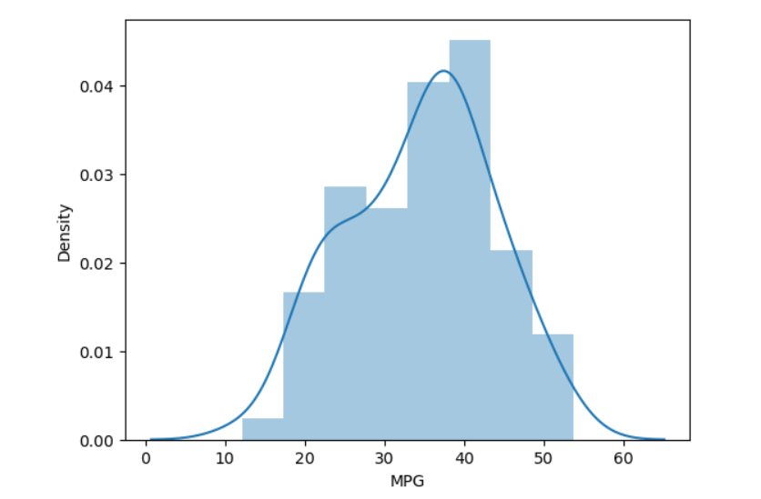

1. Check Whether the Adipose Tissue (AT) and Waist Circumference(Waist) from wc-at data set follows Normal Distribution

Dataset: wc-at.csv

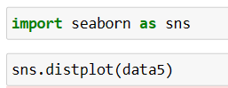

1. Normally distributed

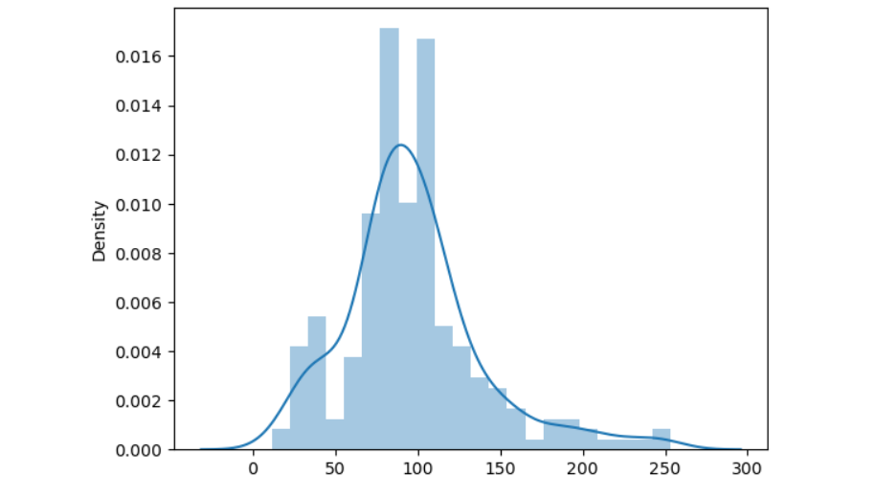

Q 22) Calculate the Z scores of 90% confidence interval,94% confidence interval, 60% confidence interval

A) 90%= 1.644

94%= 1.880

60%= 0.841

Q 23) Calculate the t scores of 95% confidence interval, 96% confidence interval, 99% confidence interval for sample size of 25

A) 95%= 2.06

96%= 2.17

99%= 2.79

Q 24**)** A Government company claims that an average light bulb lasts 270 days. A researcher randomly selects 18 bulbs for testing. The sampled bulbs last an average of 260 days, with a standard deviation of 90 days. If the CEO's claim were true, what is the probability that 18 randomly selected bulbs would have an average life of no more than 260 days

Hint:

rcode 🡪 pt(tscore,df)

df 🡪 degrees of freedom

1. 0.638

So the propability that 18 randomly selected bulbs would have avegare life more than 260 days is 63.7%